**ADVANCED SOFTWARE ENGINEERING**

**CS551**

**PROJECT PLAN (PG3)**

**TITLE: GO EASY**

**By**

Pavan Kumar Bollaram (Class ID: 7)

Preetham Kumar Danaboina (Class ID: 11)

VaraPrasad Jaggu (Class ID: 22)

Lakshmi Priyanka (Class ID: 49)

**INTRODUCTION**

**T**he vast and trending services are offering variety of public services through internet but still students attending universities at new places facing difficulty in getting the basic information. Our application ease the difficulty in grabbing the required info by collaborating all the useful info at one place by integrating web services. As of part of this application a user register to application to get the services offered and once the end user register he can get live updates of the events which user register to based on the location. This application offers other useful services as navigation to event places and other event show times. This same application can be ported to handheld devices so that user can get help with simple mobile applications across different platforms of mobiles.

**Project Goal and Objectives:**

**Overall Goal**:

Main objective and goal of this project proposal is to create a web application which comes in handy to help the new students joining in universities which are located far from their home towns. This application should provide location based services to end user and should provide options to the end user so that he can opt for services of his interest. Once the user selects the services then application should present the detailed list of services around him and end user can get alerts or voice based interactions about the live events, concerts which are scheduled at that time.

**Specific Objectives**

User notifications on mobiles and voice based alerting system are the specific objectives we are planning at this juncture and all of this implementation is completely based on location services or user can manually enter the location and get the services too.

**Significance**

The significance of this application is to provide a comprehensive user friendly details about the events which end user subscribe to and providing timing of events, directions to reach the location where the events are going to be. On the final note we can say it is simple application where one new comer to a place can find the basic required details.

**Project Background and Related Work**

College guide, NearbyMe and google’s attractions are few applications which generalizes useful information at single place by allowing user to save the time. All these applications shows the user nearby tourist attractions, theater lists, food restaurants info based on the location information provided by end user. Our application does the same kind of operations which are cited earlier in these application but the specific services provided are event notifications to user or voice based alerts which are not implemented any of these related applications.

**Proposed system**

**Requirement Specification**

Functional requirements:

* User login screen
* Dashboard with available services
* Options to provide the location manually
* Directions to reach the location or event(Navigation using Google API)
* Integrating all the web services at once place(mashup with Tabs on GUI)
* Map end user locations using google API

Non-functional requirements:

* Feel good GUI
* Quick response for the subscribed services by end user

**Framework Specification**

* **Assumptions and Principles**

Assumption is that always a novice student faces complications as he/ she attend a new school like having no idea of initial enrollment procedure, finding lecture building, housing facilities or any recreational events around him would be difficult. Also, we assume that there would a communication overhead when he attends a school in foreign land.

* **System Architecture Diagram**

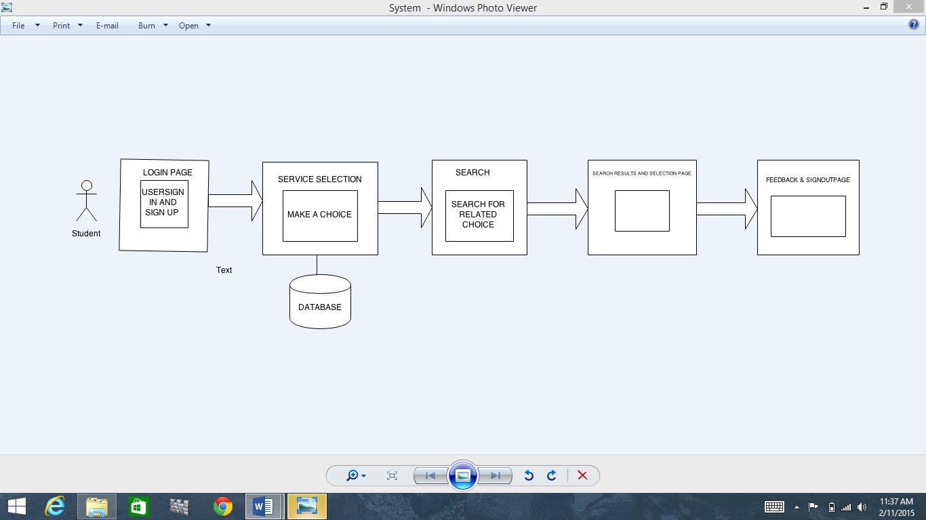

**System Specification**

1. **Existing Services:**

Map services from Google Maps

<https://www.google.com/maps?q=google+maps+umkc&rlz=1C1CHWA_enUS626US626&ion=1&espv=2&es_th=1&bav=on.2,or.r_cp.r_qf.&bvm=bv.85761416,d.aWw&biw=1366&bih=620&dpr=1&um=1&ie=UTF-8&sa=X&ei=lIzbVNKQA8b-yQTz4oDAAg&ved=0CAYQ_AUoAQ>.

RSS Feeds

[**http://feeds.finance.yahoo.com/rss/2.0/headline?s**](http://feeds.finance.yahoo.com/rss/2.0/headline?s)**=**

<http://www.kcata.org/>

**New Services to be included:**

Mash Up application where one can access at a single time university lecture building activities pop up held at that particular building.

Movie theatres and show timing API’s to be included.

**Class Diagram**

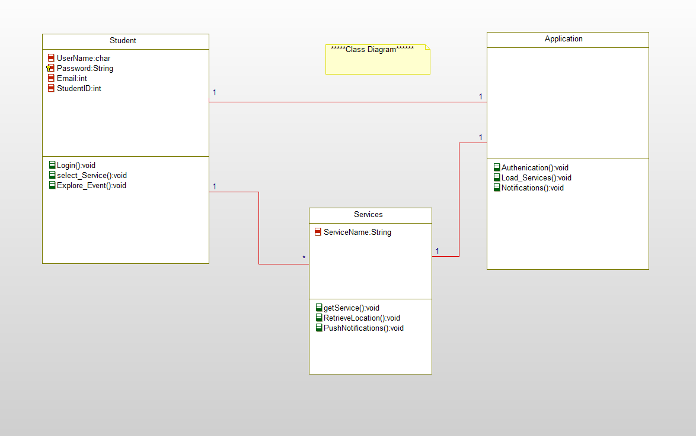

**Activity Diagram** 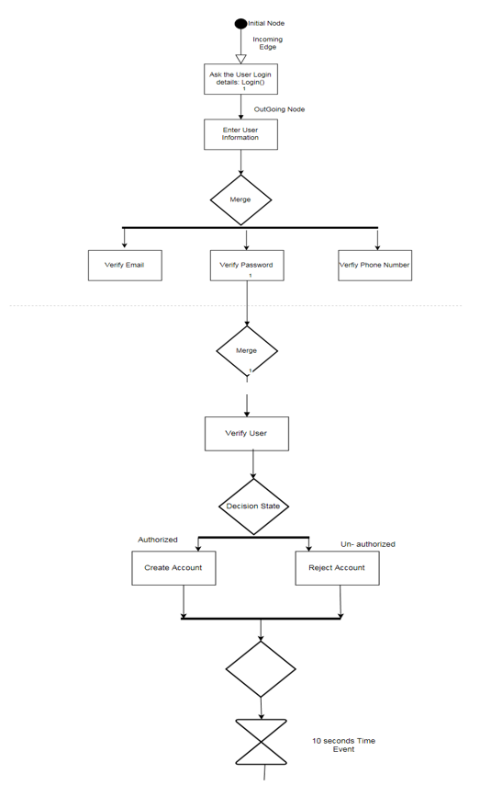\

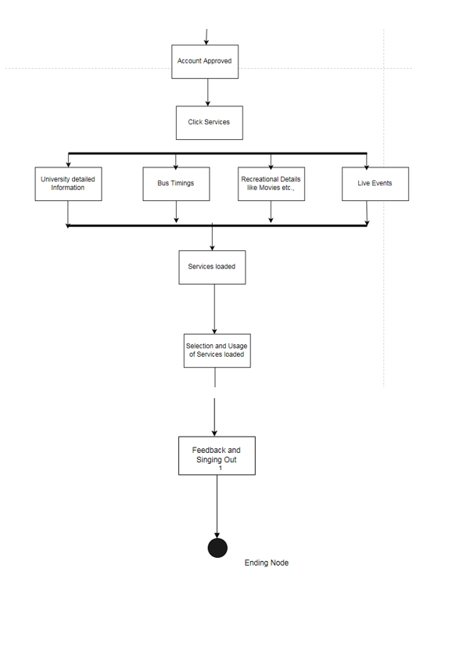**Sequence Diagram**

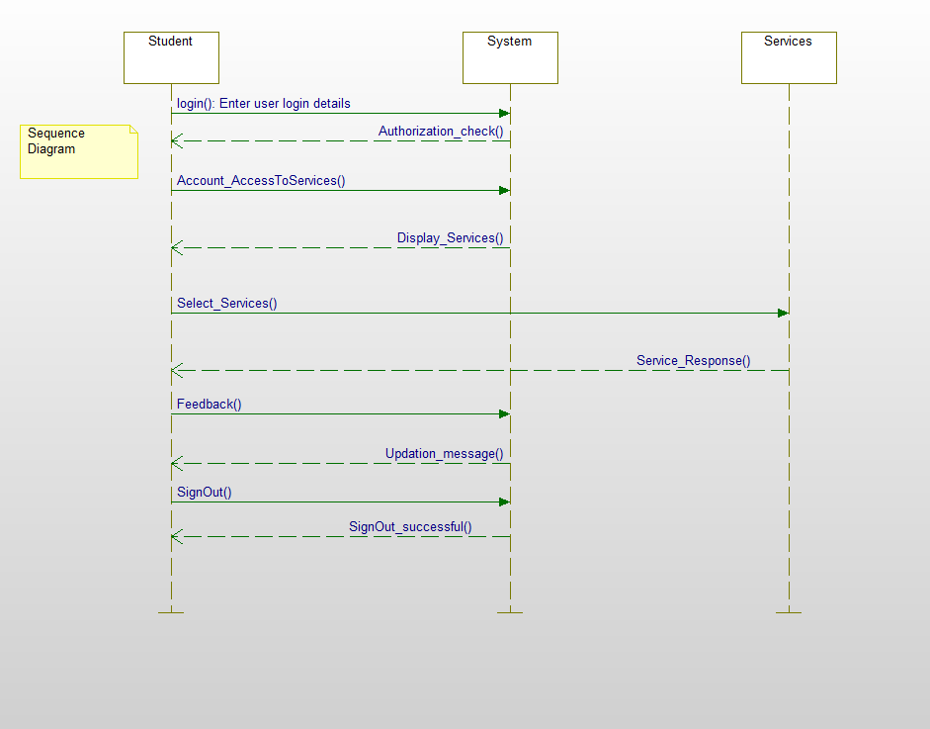

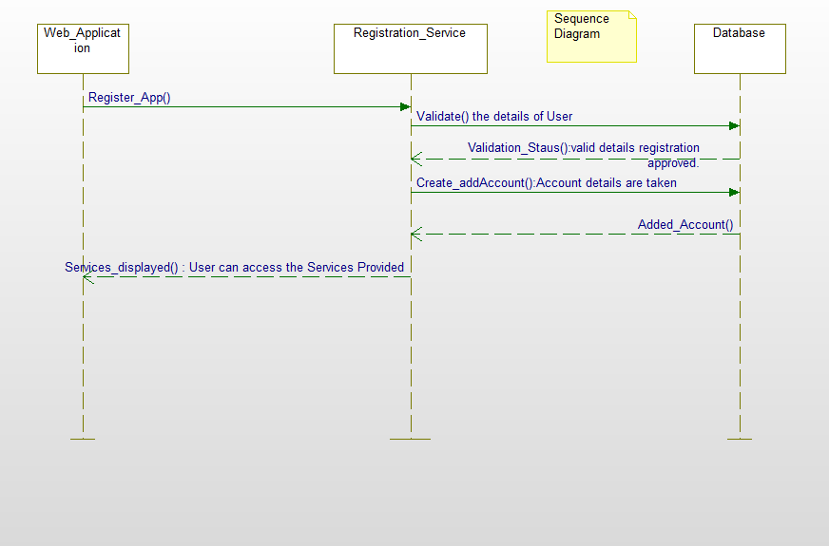

**Service Specifications:**

* The application guides the student regarding each and every activity around him without the intervention of third person.
* The User is free to access any details about the University through the service columns provided.
* The User is always assisted with google maps guiding the routes in and around University.

**Operational description:**

* The system checks for authorization while signing in for already registered user and also allows to create a account for a new user.
* The system displays featured page with every information regarding the university.
* By selecting location in university end user can track the details of selected place, events around it and bus timings and navigation from that location.

**Plan by Services (using ScrumDo)**

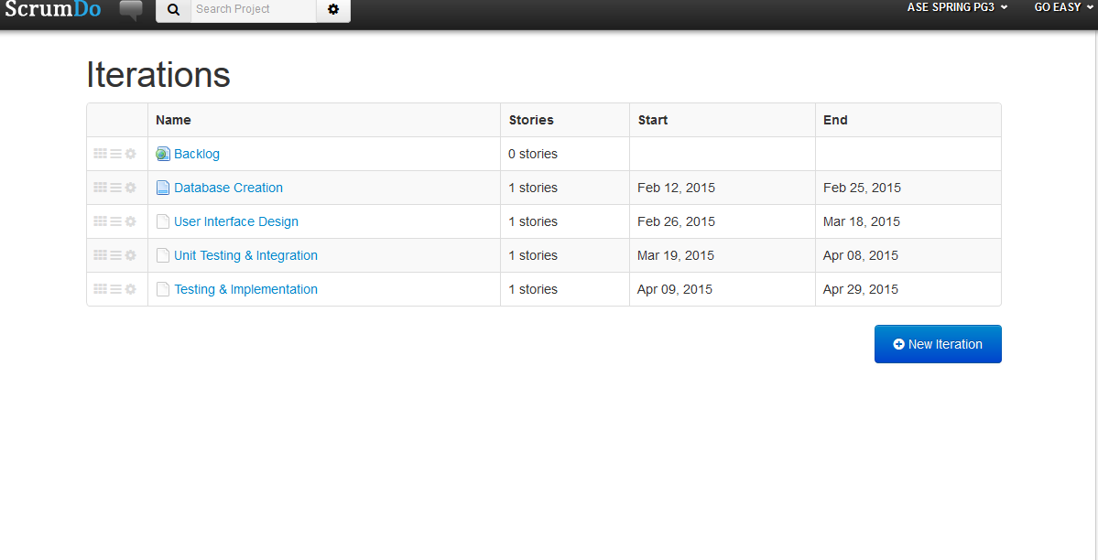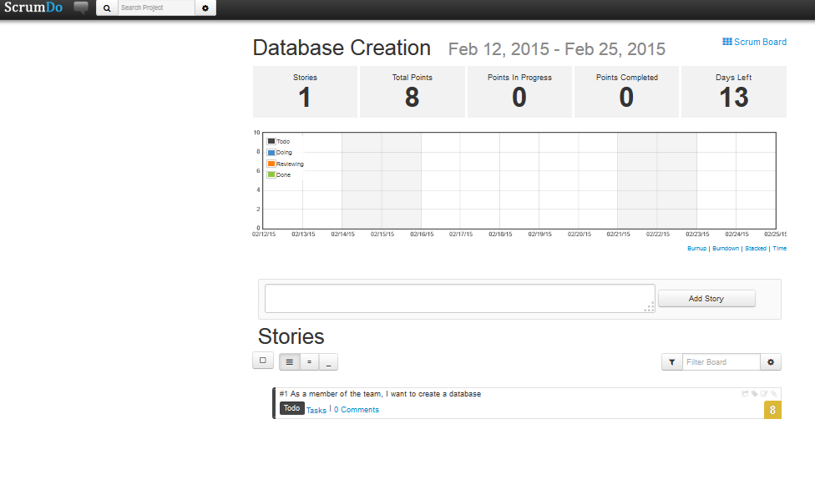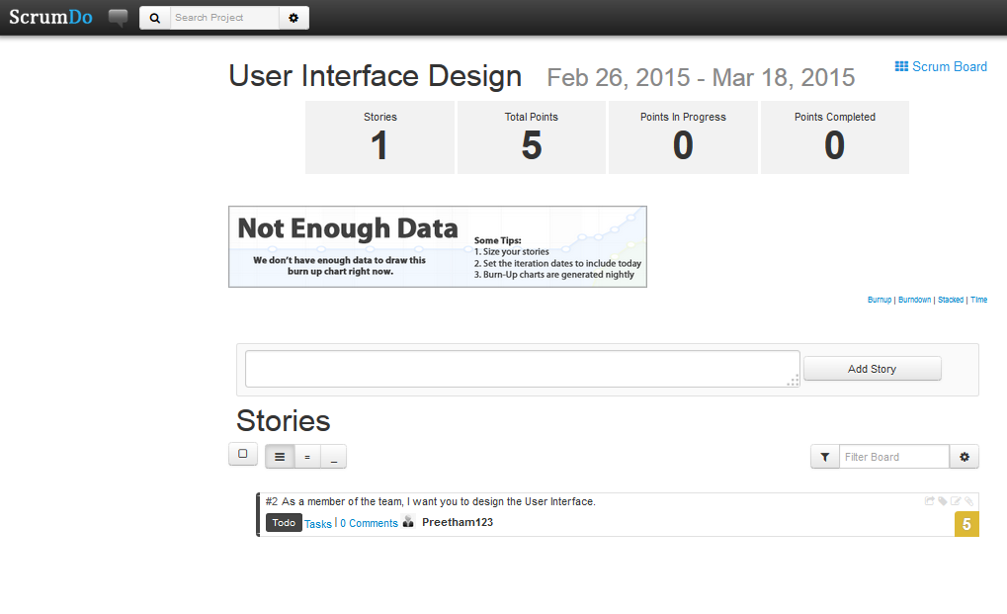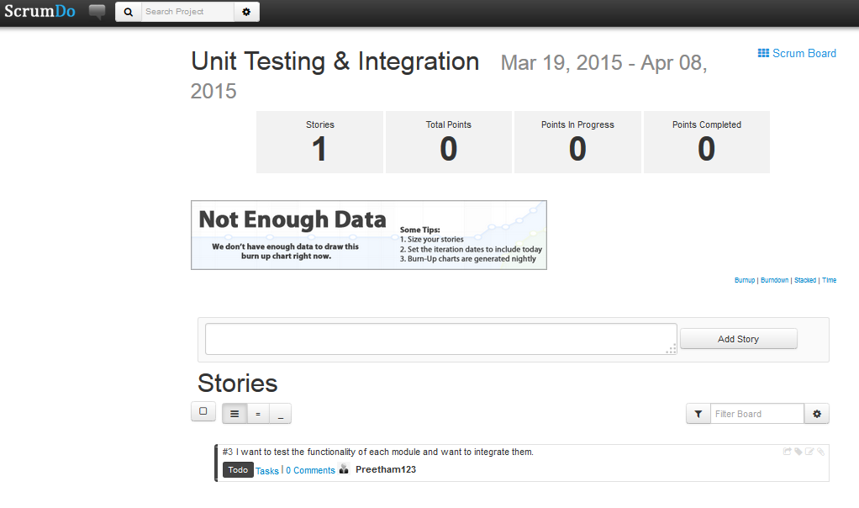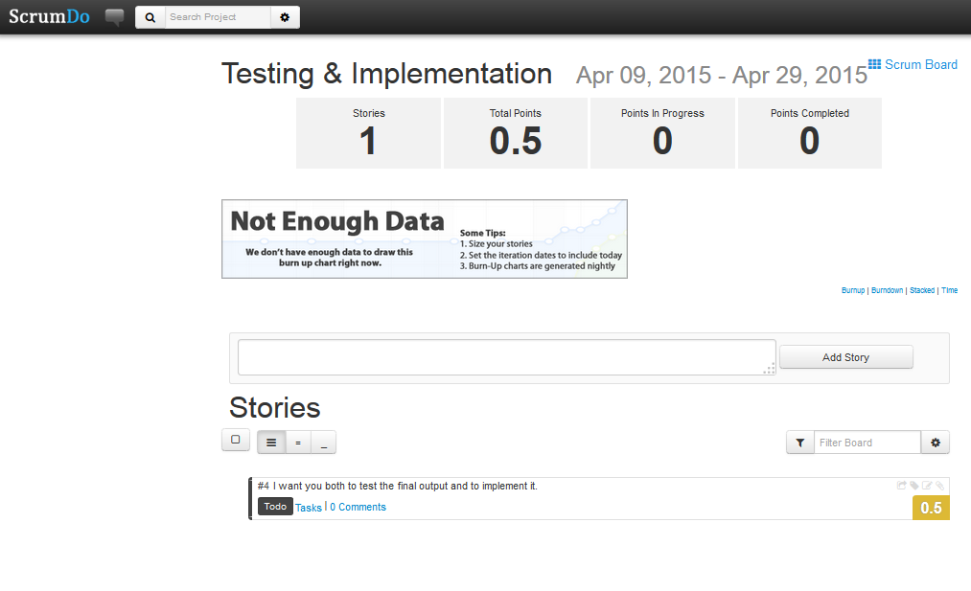

**Risk Management**

1. Since we are showing all the live Events going nearby we have to be up to date with the Database.

2. Our application should be compatible with the handheld devices and web applications.

3. We should be careful while uploading the events into the Database.

4. Response time of the application shouldn’t be too slow and it cannot be off grid due to overload.

**Posting the class google site:** https://docs.google.com/spreadsheets/d/1QtbhKeCep4SvzP5gCYs1iGPyKQxhooCoGqLR5uYl8/edit#gid=2115159985

**Bibliography**

Google Maps API for Business <https://developers.google.com/maps/documentation/business/>

My-Spare Time <https://www.youtube.com/watch?v=Bf0_ZsJQxD8>

[**http://www.kcata.org/maps_schedules/**](http://www.kcata.org/maps_schedules/)

http://www.youtube.com/watch?v=w7TIS6NYdtk&feature=youtu.be

**https://www.zomato.com/mobile**

**https://play.google.com/store/apps/details?id=com.tweakersoft.aroundme&hl=en**